



Business Requirement Document
Supply Chain Management
NWS Supplier Renewal Fee
DOCUMENT FOR

Table of Contents:
Table of Contents: 1
1. Introduction 2
1.1 Business Need 2
1.2 Expected Business Outcomes 2
1.3 Project Scope Summary 2
2. Business Requirement Details 3
2.1 Requirement Description 3
2.2 Functional Requirements 3
2.3 Non-Functional Requirements 4
3. System Integration 5
4. Business Classification Fields 5
5. Payment Details 6
6. Process Flow 6
6.1 Supplier Renewal and Payment Flow 6
7. Assumptions & Constraints 7
8. Application Prototype 8
9. Risks & Mitigation 9
10. Open and Closed Issues 9
10.1 Open Issues 9
10.2 Closed Issues 9

1. Introduction

1.1 Business Need
Nama Water Services requires a structured supplier renewal process to ensure supplier business classification data remains current and valid. The existing supplier records in Oracle Fusion Supplier Master require periodic renewal for compliance and governance. Non-Riyada suppliers must renew every two years from the date of registration, while Riyada suppliers must renew based on their Business Classification expiry date. The system should automate notifications and fee processing to minimize manual intervention.

1.2 Expected Business Outcomes
- Automated renewal notification and fee payment process.
- Improved supplier data accuracy and classification validity.
- Integration with Bank Muscat for seamless payment and AR processing.
- Exemption handling for Riyada suppliers.
- Transparent renewal tracking and approval process.

1.3 Project Scope Summary
- Development of a custom Supplier Renewal Page linked via Nama website and Email notifications.
- Integration with Bank Muscat payment gateway.
- Automated AR receipt generation for Non-Riyada payments.
- Fee exemption logic for Riyada suppliers.
- Supplier Master integration for business classification update post approval.
- Notification triggers at 30, 15, and 1 day before expiry and supplier will be inactivated if renewal is not done.

2. Business Requirement Details

2.1 Requirement Description
Suppliers will receive renewal notifications via email and Nama Website prior to their renewal due date. The custom renewal page will allow suppliers to enter their CR number, which retrieves supplier information (Name, Number, Type, and existing Business Classification). Suppliers will update their classification details, including new start and expiry dates, and upload the required attachments.
For Non-Riyada suppliers, a renewal fee of 50 OMR will apply. For Riyada suppliers, the fee will be automatically exempted. Once payment is completed and status updated as 'Paid', the supplier submits the renewal for approval. Upon successful approval, updated details will sync with Oracle Supplier Master.

2.2 Functional Requirements
Functional Requirement | Detailed Description
Custom Renewal Page | Custom page to capture CR number, retrieve supplier details, and allow updates to business classification fields and attachments.
Riyada Fee Exemption | System auto-exempts Riyada suppliers from the renewal fee.
Payment Gateway Integration | Integration with Bank Muscat for 50 OMR renewal fee with callback confirmation.
Supplier Deactivation | If renewal not done supplier profile will be deactivated and upon on renewal it needs to be activated through API
Automated Notification | System sends renewal reminders at 30, 15, and 1 day before expiry via email and Nama website.
AR Receipt Integration | Automatic AR receipt creation upon successful payment.
Approval Workflow | Submitted renewal requests trigger supplier profile change approval in Oracle Fusion.
Re-submission Handling | Failed approval requests can be re-submitted using previous payment records.

2.3 Non-Functional Requirements
- Security: All data must be transmitted over HTTPS and payment data must not be stored.
- Performance: Response time < 3 seconds.
- Availability: System uptime 99.5%.
- Scalability: Must support concurrent supplier renewals.
- Audit: All activities logged for traceability.

3. System Integration
System | Module | Integration Point
Custom Renewal Page | Supplier Portal | Business Classification Update, Payment Initiation
Bank Muscat Gateway | Payment | Real-time payment processing and confirmation callback
Oracle Fusion | AR | AR Receipt Creation and accounting integration
Oracle Fusion | Supplier Master | Classification updates post approval

4. Business Classification Fields

Field Name | Description | Mandatory
Certificate Number | Business Classification Certificate Number | Yes
Business Classification Type | LOV values: MOC, CR, RIYADA | Yes
Start Date | Start date of new classification | Yes
Expiry Date | Expiry date of new classification | Yes
Attachments | Scanned copies of classification documents | Yes

5. Payment Details
Payment Gateway: Bank Muscat
Renewal Fee: 50 OMR (Non-Riyada Suppliers)
Fee Exemption: Riyada Suppliers
AR Receipt: Auto-created upon successful payment
Payment Mode: Online (Credit/Debit Card, Bank Transfer)

6. Process Flow

6.1 Supplier Renewal and Payment Flow
1. System sends renewal link via email and Nama website.
2. Supplier enters CR number on the renewal page.
3. System retrieves supplier details.
4. Supplier updates business classification and uploads attachments.
5. For Non-Riyada, system redirects to Bank Muscat for payment.
6. Payment confirmation updates status as 'Paid' and triggers AR integration.
7. Supplier submits renewal for approval through integration needs to be submitted as Supplier profile change request
8. On approval, updates reflect in Oracle Supplier Master.
9. Failed or rejected renewals can be re-submitted without repayment.
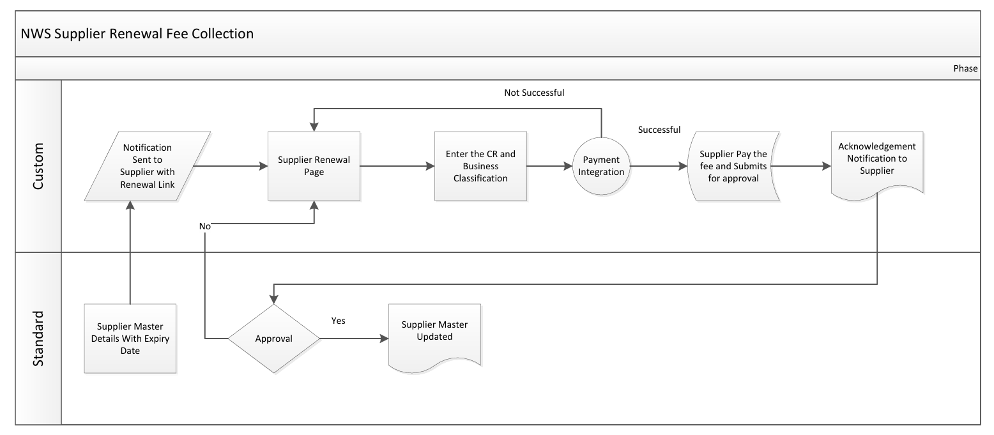

7. Assumptions & Constraints
- Payment transactions handled securely.
- Riyada determination based on supplier Type.
- Integration APIs active and monitored.
- Attachments within size and format limits.

8. Application Prototype
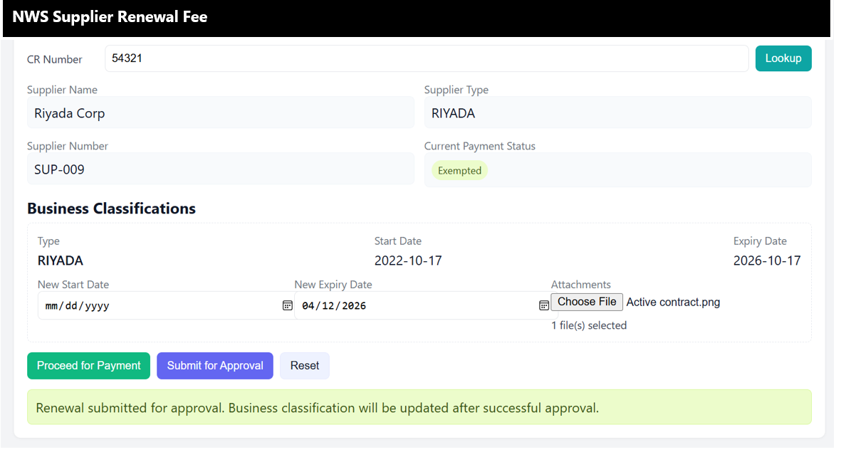

9. Risks & Mitigation
Risk | Impact | Mitigation
Payment Failure | Supplier renewal delayed | Implement retry and error notification.
Integration Failure | Data not updated in Oracle | Implement monitoring and retry logic.
Notification Failure | Suppliers may miss renewal | Enable fallback email resend logic.

10. Open and Closed Issues

10.1 Open Issues
S. No | Issue | Resolution | Responsibility | Target Date | Impact Date
1
2

10.2 Closed Issues
S. No | Issue | Resolution | Responsibility | Target Date | Impact Date
1
2

